NOTICE OF VACANCY

Election of councillor to Broughton Parish Council
Local Government Act 1972 (Sec. 87(2))
NOTICE IS HEREBY GIVEN

that due to the resignation of Councillor Mr Patrick Gorrill a casual vacancy has arisen in the Office of Councillor for the Parish Council.

If by 9th February 2022 (fourteen days after the date of this notice, excluding Saturdays, Sundays and Bank Holidays) a request for an election to fill the vacancy is made in writing* to:

The Returning Officer
Allerdale Borough Council
Allerdale House
Workington
CA14 3YJ
by TEN electors for the Electoral Area**, an election will be held to fill the vacancy
otherwise the parish council will fill the vacancy by co-option.

If an election is called, it will be held by the date set by Allerdale Borough Council in 2022.

Dated 23rd January 2022

Signed 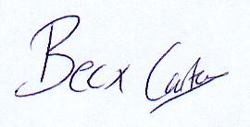 Clerk to the Parish Council

*Letters to the Returning Officer can be sent by email to electoralservices@allerdale.gov.uk
** The request must come from TEN Local Government Electors for the Parish (or the Parish Ward where the Parish is Warded).

