Allotment Measuring Process (Broughton Parish Council)

Prior to the commencement of the new tenancy agreement & pricing structure all plots were remeasured by the site representatives of the Allotment Working Group (Mr Alan Nelson, Mr Carl Jackson & Mr Mark White). The following process was followed for all measurements and will be followed in future for any measuring required for future subdivide plots.

- Plots measured along the plot edges using a meter tape
- Plots were measured to 2 decimal places
- Measurements were marked out on a site map which is retained and held by the Clerk for record purposes
- Square Meter Calculations were done using length * width geometric calculation
- Where opposing side measurements differed, the opposing relevant sides were added together and divided by 2 to obtain an average (see below for the side diagrams) for the Sq M calculation.
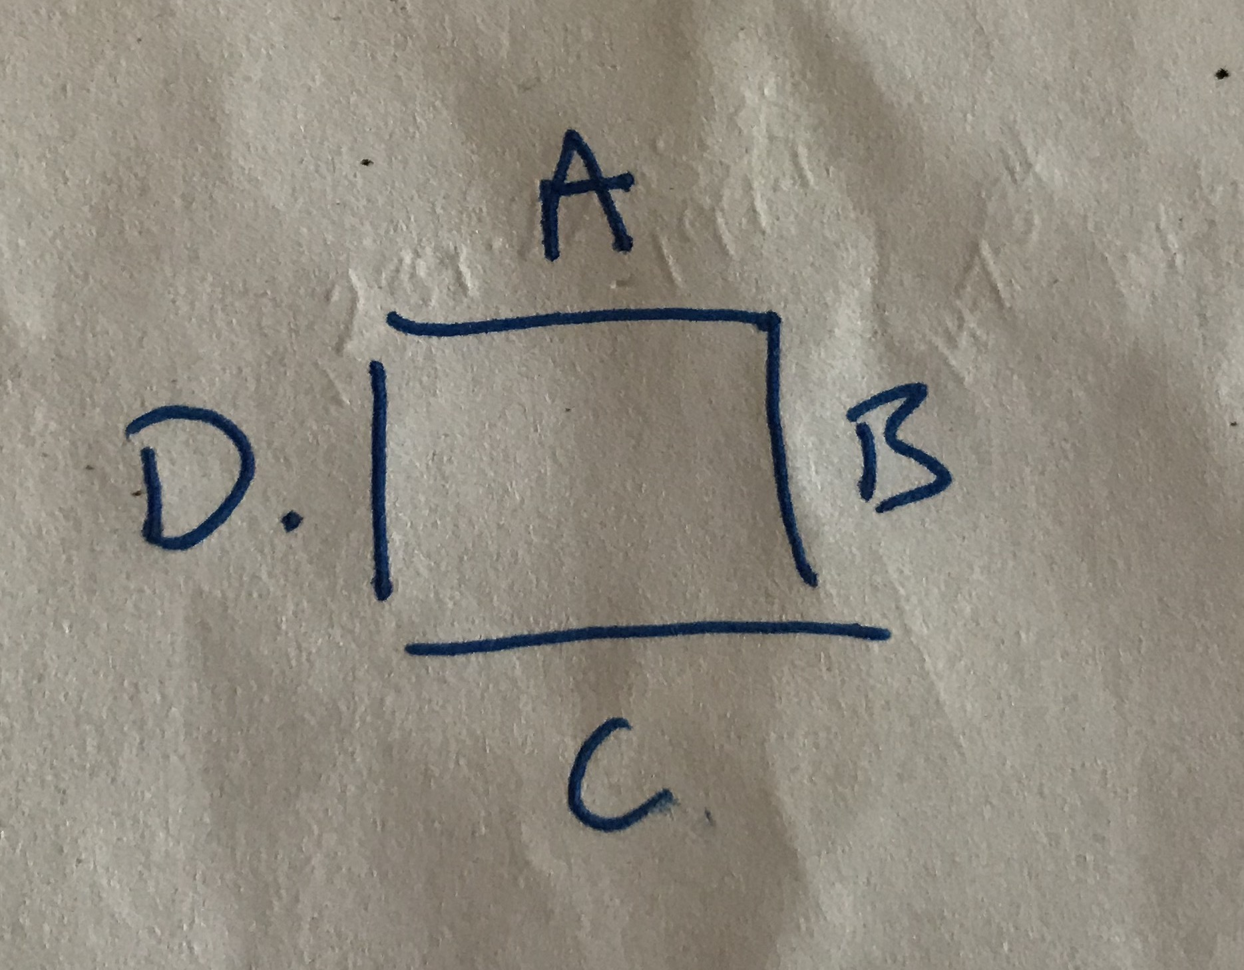
- The calculation used for the average side dimension is a + c / 2 or d+b / 2
- Where plots were inaccessible at the time of measuring the measurements obtained by Newcastle University Students were used for the purposes of budget calculation. These plots will be measured as and when they become free and prior to being reallocated.
- All measurements & associated calculations are recorded on a master spreadsheet held by the Clerk and supported by the map at 3) above.

Adopted by Broughton Parish Council 20th August 2018

